- Purpose

The purpose of this document is to describe the specifications and design that will be implemented for the process of persisting the finger images that are caught just before the energized capture.

- General Requirements

Where appropriate, logic should be contained in try/catch blocks and any exceptions should be logged using the standard logging mechanisms.

- Specifications

Requirement #1: The saving of the image must work for both user roles (administrator and user).

Specification: The process of capturing the finger image just before the energized image is captured is not dependent in any way on the logged in user or the user’s role. The implementation of the finger image capture is encapsulated in a single instance of code that is accessed by all users and roles.

Requirement #2: The image must be saved with the same detail level that is it is captured with.

Specification: The finger image is captured with the same image setting as the energized image. The bitmap is then turned into a byte stream through a direct conversion (no loss of information) and then saved into the database. This process will ensure that the image will not lose any detail when it is extracted or saved.

Requirement #3: The image must be retrievable during the viewing of a capture.

Specification: The finger image is stored in the same manner as the energized image. New methods have been added to the code in order to be able to retrieve the finger image in the same manner as the energized images are retrieved and displayed.

Requirement #4: The View Capture window will be modified to display the finger image along with the energized image.

Specification: The view capture process has been modified to allow the retrieval and display of the captured finger image. The finger image is shown to the right of the energized image and will be shown with an orientation indicator.

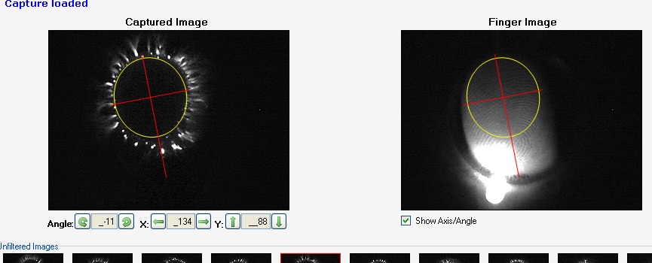
In the case of a set of energized images that do not have an associated set of finger images, a message will be displayed to alert the user, see below:

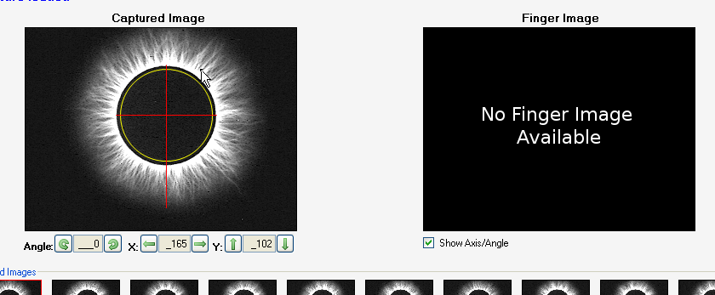

Requirement #5: The capture process window will be modified to display the finger image along with the energized image.

Specification: The capture process was modified to display both the finger image as well as the energized image during the scan process. The 'preview window' as it is commonly known will now server a dual function:

- To display the live preview, so the finger can be properly aligned before the energized image is captured.
- To display the associated captured finger image when reviewing the energized image for proper alignment.

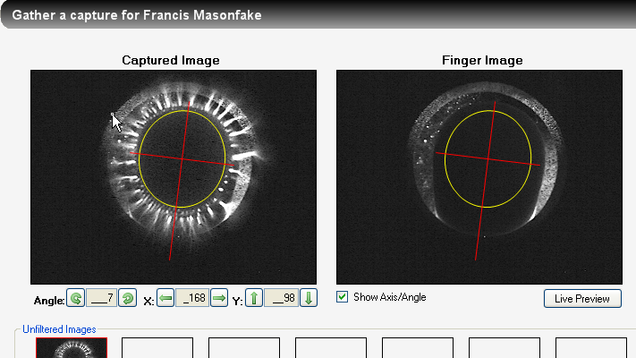
A button labeled 'Live Preview' has also been added in order to allow an image to be recaptured when reviewing the display.

Document Revision History
Version Number: | Description of Change: | Date: | Updated by:
000 | Introduction | 5/24/11 | A. Mason

